|  |  |
| --- | --- |
| **Ex.No:10** | **Find the most frequent words in a text read from a file** |
|  |

***Aim:***

To develop a python program to Find the most frequent words in a text read from a file.

***Algorithm:***

|  |  |
| --- | --- |
| **Step 1:** | Start Process |
| **Step 2:** | Open input file |
| **Step 3:** | Read all the data into single string called data |
| **Step 4:** | Split data based on space “ ” and make a word list. |
| **Step 5:** | Take every word and compare with all the words |
| **Step 6:** | If matched increase the count of particular values by 1 |
| **Step 7:** | Else ignore the word. |
| **Step 8:** | If all the words compared the find the maximum count value then display the associated words |
| **Step 9** | Stop Process |

**Flow Chart:**

**Pseudo Code Prime Finder:**

START

READ file_contents in data

SET word_list = CALL split_words(data,” ”)

WHILE no words to compare in word_list THEN

Current_Word = CALL get_word()

CALL move_to_next_word()

WHILE no_words to compare from Current Word THEN

Next_Word = CALL get_word()

IF Current_Word =Next_Word THEN

Current_Word_Count += 1

ELSE

Current_Word_Count = 1

END IF

CALL move_to_next_word()

END WHILE

CALL move_to_next_word()

END WHILE

SET Max_value = CALL max_finder with Word Count

WHILE no words to compare in word_list THEN

Current_Word = CALL get_word()

Current_Word_Count = CALL get_word_count(Current_Word)

IF Max_value equls to Current_Word_Count THEN

PRINT Current_Word

END IF

END WHILE

STOP

**Program:**

in_file = open("input_file.txt","r")

data = in_file.read()

print(data)

word_list = data.split(" ")

word_dictionary = {}

for word in word_list:

if(word in word_dictionary):

word_dictionary[word] += 1

else:

word_dictionary[word] = 1

max_frequency = max(word_dictionary.values())

print(max_frequency)

print("Maximum Repeated Words")

print("----------------------")

for word in word_dictionary:

if(word_dictionary[word]==max_frequency):

print (word)

**Output:**

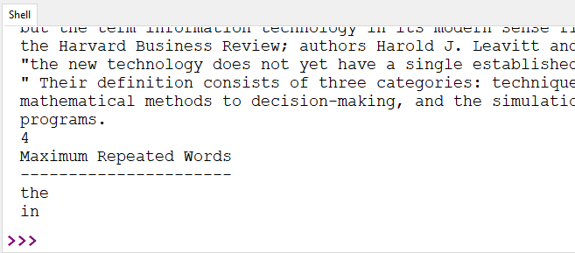

***Result:***

Thus the python program Find the most frequent words in a text read from a file was developed and tested successfully.